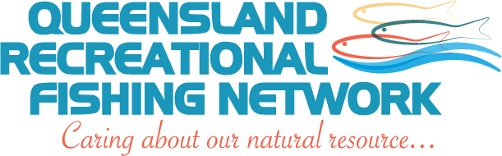
MEDIA RELEASE
Finally Recreational Fishing a Serious Election Issue
The Queensland Recreational Fishing Network has welcomed the ALP policy announcement today, that if elected on Saturday, they will establish three initial net free areas (NFA’s) in Queensland – Trinity Inlet at Cairns, a section of coast just north of Mackay and the mighty Fitzroy River in Central Queensland.
Recreational fishing groups the length of the state have been calling for dedicated areas adjacent to population centres to be set aside as net fee areas for years, but until now, no political party has seriously embraced the concept at a policy level.
Local spokesman for the QRFN, Mr ……………. said the commitment by the ALP to declare three initial NFA’s was a watershed in fisheries management in Queensland and a brave decision that would be enthusiastically recognised by recreational fishers across the state.
“This is a once in a lifetime opportunity for genuine reform to commence in our heavily over-fished inshore fishery and fish stocks to begin to be rebuilt,” Mr ……said.
“Finally after all the years of seemingly fruitless campaigning to get successive governments to recognise the dire straits our inshore fishery is in, a major party has bitten the bullet and followed the lead of other states in Australia in developing a plan to reduce and remove commercial netting from key locations and introduce best practice fisheries management to ensure the future of fish stocks and the ongoing opportunity for Queenslanders to engage in their favourite pastime of wetting a line,” Mr …… explained.
The QRFN is encouraging recreational fishers and their families in those seats where constituents will directly benefit from having net free areas declared, to use their vote wisely on Saturday to send a clear message to all political parties that recreational fishers want a better deal and are prepared to cast their vote accordingly.
Mr …….. said that traditionally advocacy groups like the QRFN had not overtly encouraged recreational fishers to vote one way or the other at election time, however he said that this time things were very different, with one party adopting a positive, progressive position that offers the hope of a bright future and a real change of attitude towards sustainably and fairly managing Queensland’s fish stocks into the future.
“We want a future where Queensland is recognised nationally and even internationally as having the most diverse, accessible and sustainable recreational fishery in Australia,” Mr …….. said. “Well over one million Queenslanders love to catch and eat their own local fresh fish and it’s high time this large segment of the population was acknowledged and assured of the ongoing opportunity to continue to do what has always been an integral part of the Queensland lifestyle,” Mr ……. said.
The QRFN is confident that once NFA’s are proven to be a success, other areas of the state will be progressively included in a network of NFA’s and that recreational fishers in those areas should not be disappointed that they haven’t been included in the initial round, but be excited about the very likely prospect of seeing a Net Free Area in their backyard in the not too distant future.

Contact: Mr…………………..
Phone:
Email:
Website: www.qrfn.org

28 January 2015

